NEW 3-PIECE FLAT-TRAY ASSEMBLY
SAVES ON SHIPPING COSTS & KEEPS PRICES DOWN!
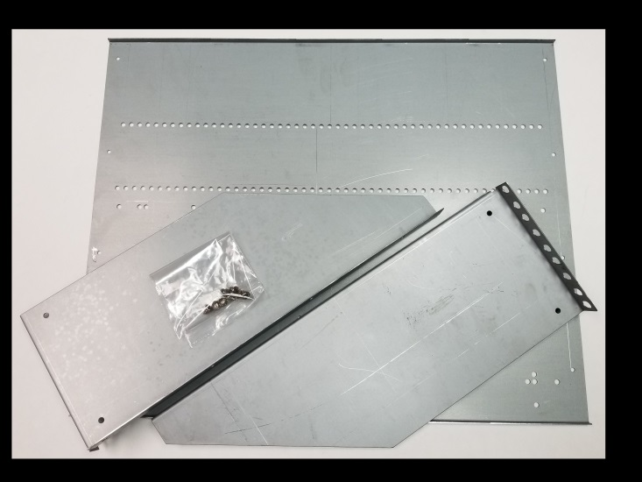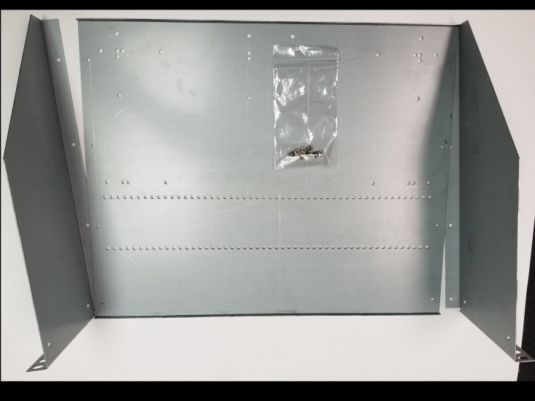
NOTE: STIFFENING LIP AT FRONT AND REAR OF BASE PLATE FACES UPWARDS
STAND THE WINGS UP AND SLIP THEM UNDER THE BASE TO SEE HOW THEY ALL WILL FIT TOGETHER
ON ARRIVAL THEY LOOK LIKE THIS

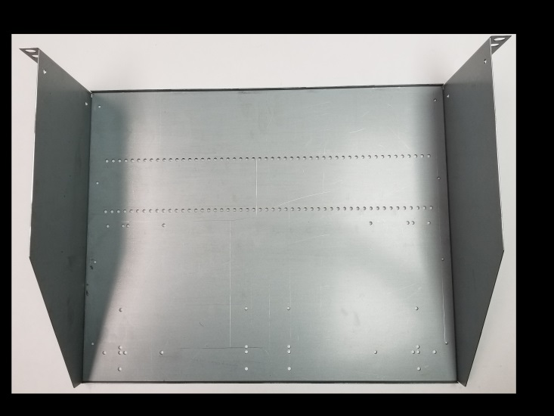
TURN THE TRAY BASE OVER, LINE UP THE HOLES, SCREWS GO IN LEFT & RIGHT SIDES FINISHED TRAY LOOKS LIKE THIS PICTURE
STEPS TO ASSEMBLING THE NEW 3-PIECE FLAT TRAY:
- YOU WILL NEED ONLY A SCREWDRIVER FOR ASSEMBLY
- BOTTOM PLATE STIFFENING LIPS NORMALLY FACE UP FOR STRENGTH
- SLIP THE WINGS UNDERNEATH THE LEFT & RIGHT SIDES OF THE TRAY BASE
- NOTE THAT THE 2 ROWS OF BASE PLATE HOLES ARE IN THE FRONT END
- 8 SHEET METAL SCREWS ARE PROVIDED TO INSTALL UP FROM THE BOTTOM
- THE SCREWS ARE LITERALLY ‘MAKING NEW THREADS’ SO THEY ARE TIGHT!
STILL HAVE QUESTIONS? CALL OUR WILDLY BRILLIANT TECHNICANS!
www.Novexcomm.com 310.534.4456 M-F 10-6 Pacific (California) time
WORKING HARD TO KEEP THE COSTS LOW & PRICES LOWER FOR YOU!

